
Story

Date | 29 October 2026
Team ID | [Enter Team ID]
Project Name | Electric Vehicle Market Performance & Insights
Maximum Marks | 5 Marks

By using stories in Tableau, you can effectively communicate complex data in a way that is both interactive and engaging, making it easier for the audience to follow along and understand the insights. It’s a tool for data storytelling, allowing you to present insights in a cohesive, engaging way that takes viewers through a logical progression of findings or analyses.
In Tableau, Story is a feature that allows you to create a sequence of dashboards, visualizations, and text to present data insights in a cohesive and narrative-driven way. It's like a slideshow within Tableau that guides the audience through a series of data points, helping them understand key insights, trends, or outcomes of your analysis.

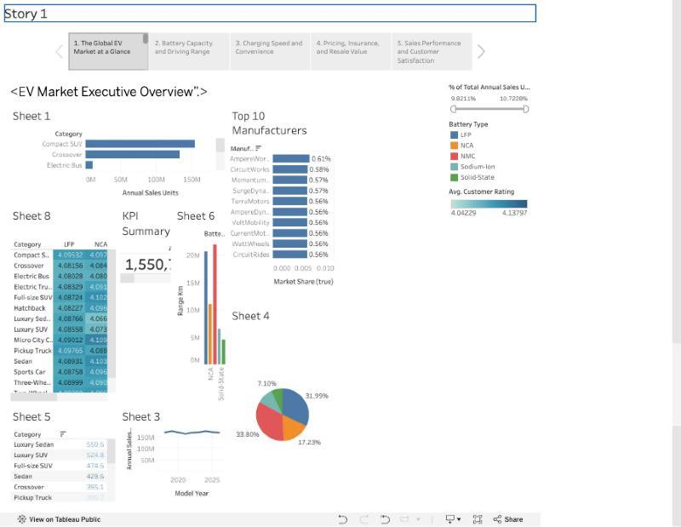
Story point 1 – The Global EV Market at a Glance: the EV Market Executive Overview dashboard (KPIs, category sales, Top-10 manufacturers, battery mix, range, rating heatmap, sales trend).
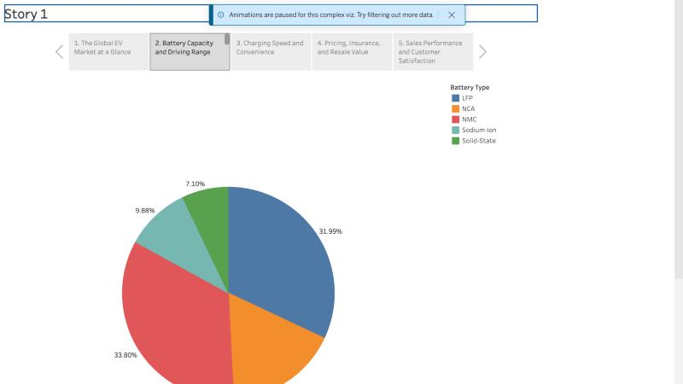
Story point 2 – Battery Capacity and Driving Range: battery-type share of annual sales (NMC 33.80%, LFP 31.99%, NCA 17.23%, Sodium-Ion 9.88%, Solid-State 7.10%).
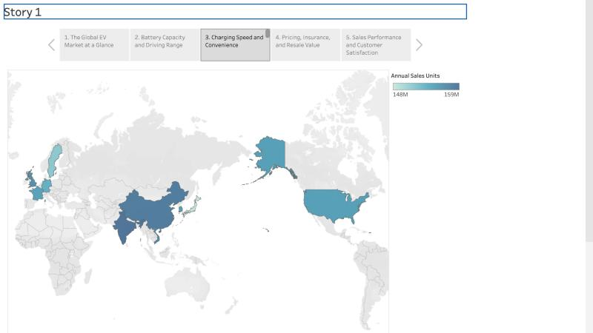
Story point 3 – Charging Speed and Convenience: annual sales by manufacturing country (148 M – 159 M units).
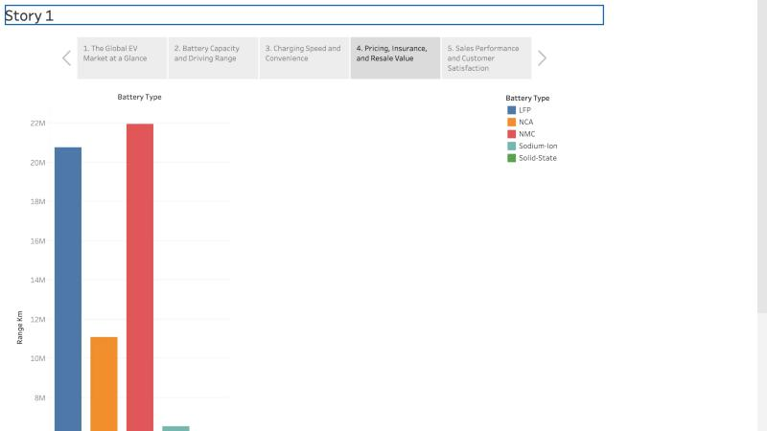
Story point 4 – Pricing, Insurance, and Resale Value: total driving range by battery type.
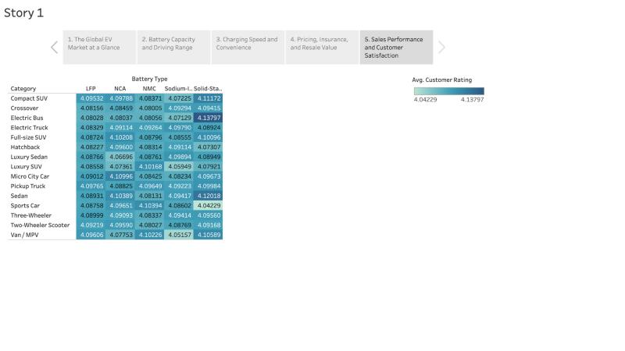
Story point 5 – Sales Performance and Customer Satisfaction: average customer rating by category × battery type.

Observations:
- Two-Wheeler Scooters Lead Sales: Two-Wheeler Scooters are the largest category with 174.6 M units (11.3% of total annual sales), ahead of Hatchbacks (154.9 M) and Compact SUVs/Sedans (153.4 M).
- NMC and LFP Dominate Battery Technology: NMC (33.80%) and LFP (31.99%) together power almost two-thirds of sales; Solid-State (7.10%) and Sodium-Ion (9.88%) are emerging next-generation chemistries.
- Balanced Global Manufacturing: All 10 manufacturing countries produce between 148 M and 159 M units – India (159.2 M) and China (158.5 M) lead, Japan (148.3 M) is lowest.
- Consistently High Customer Satisfaction: Average ratings range only from 4.04 (Sports Car, Solid-State) to 4.14 (Electric Bus, Solid-State); the overall average is 4.09/5 and the top-10 manufacturers hold just 5.7% share, showing a competitive, fragmented market.

Activity 2:
Publish Story on Tableau Public and Paste Public link below
https://public.tableau.com/app/profile/rajlaxmi.pandey/viz/Book2_17936085689820/Story1

